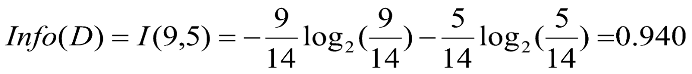

-0.64 \* LOG2(0.64) - 0.35 \*LOG2(0.35)

-0.64 \* ( LOG10(0.64)/ LOG10(2) ) - 0.35 \*( LOG10(0.35)/ LOG10(2))

-0.64 \* ( LOG10(0.64)/ 0.3010) - 0.35 \*( LOG10(0.35)/ 0.3010)

LOG10(0.64)= -0.1938, LOG10(0.35)= -0.455

LOG10(2) = 0.3010

-0.64 \* ( -0.1938/ 0.3010) - 0.35 \*( -0.4472/ 0.3010)

=0.4098 + 0.5305

=0.94

Ganpat University- U. V. Patel College of Engineering

KETAN SARVAKAR

298